**PRACTICAL-4.1**

**AIM:**STATIC ROUTING

**THEORY:**

Static routing is a routing type in which a network administrator configures the routes into the routing table to be used by the router to send packets to a destination network.

A default static route is used to send packets when an explicit route is not present in the routing table. This route is configured with 0.0.0.0/0 as its destination IPV4 address. By configuring a default static route, a router can match all packets to use this route.

Static routing is a form of routing that occurs when a router uses a manually-configured routing entry, rather than information from dynamic routing traffic. In many cases, static routes are manually configured by a network administrator by adding in entries into a routing table, though this may not always be the case. Unlike dynamic routing, static routes are fixed and do not change if the network is changed or reconfigured. Static routing and dynamic routing are not mutually exclusive. Both dynamic routing and static routing are usually used on a router to maximise routing efficiency and to provide backups in case dynamic routing information fails to be exchanged. Static routing can also be used in stub networks, or to provide a gateway of last resort.

**TOPOLOGY:**

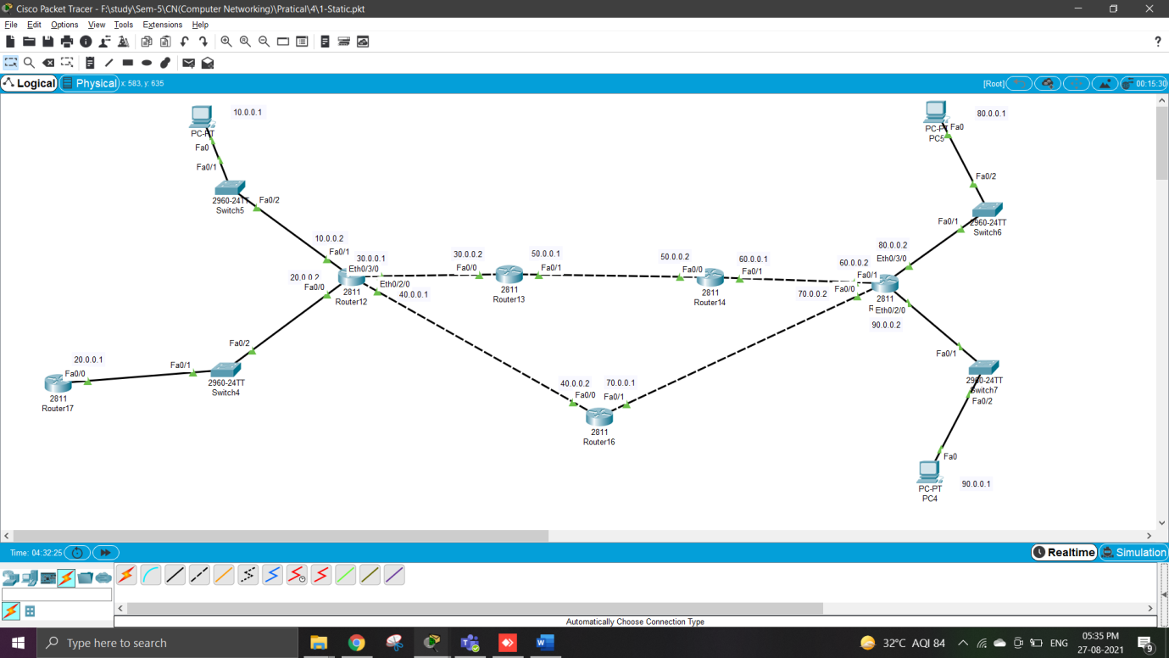

**COMMAND:**

Route17:

* In this first we have to arrange router , pc and switches .
* Than connect all together.
* After connection give pc to their ip address.
* Than after take first router and give it to ip addresses and and set it.

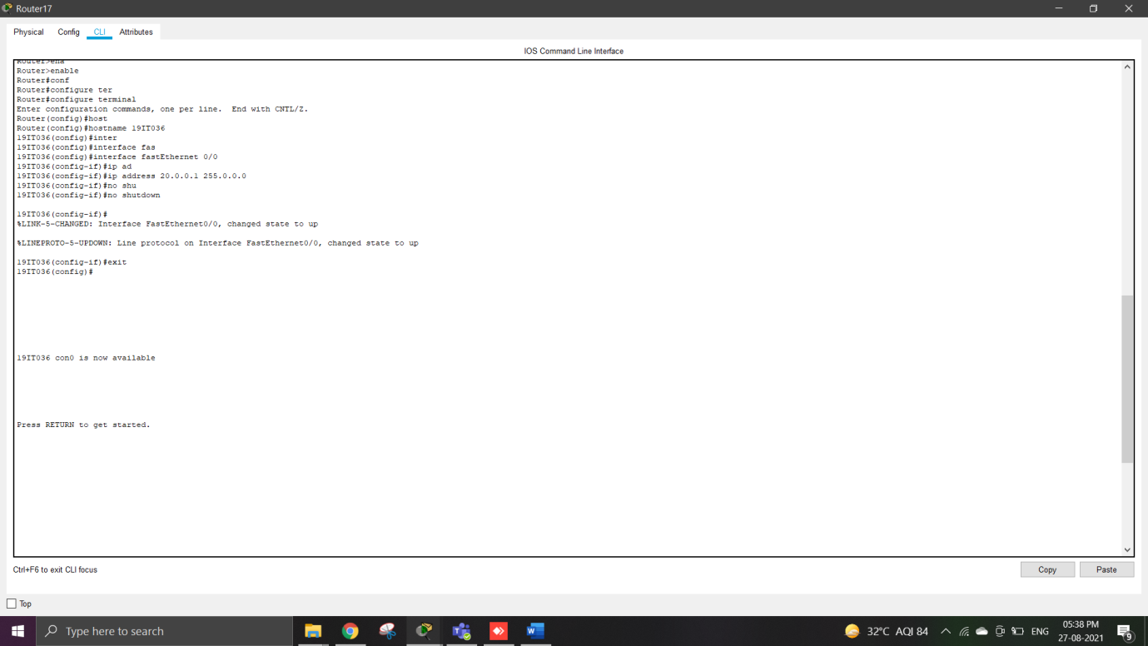

* After set ip addresses for static and default routing we have to use command ip route 30.0.0.0 255.0.0.0 20.0.0.2.
* Like this we have to use command for all other routers.

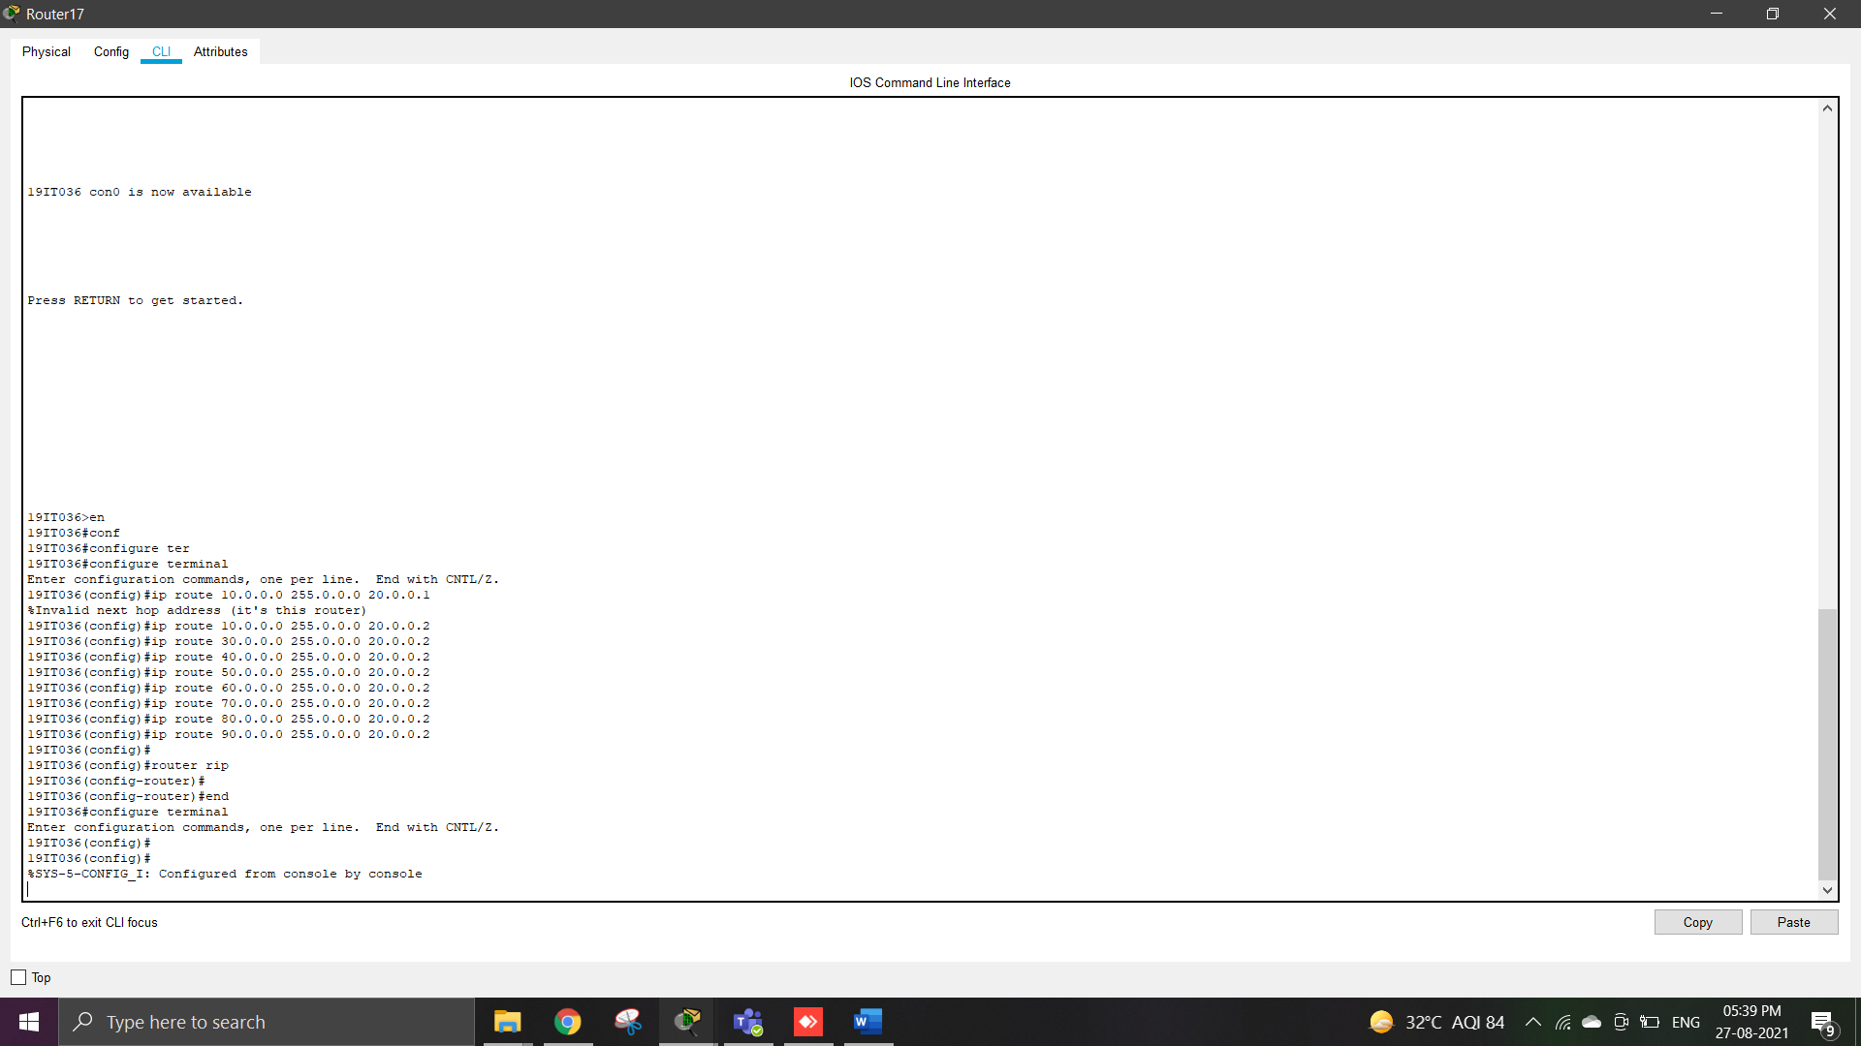

Route12:

* In router 12 first set ip address and than use command for routing.

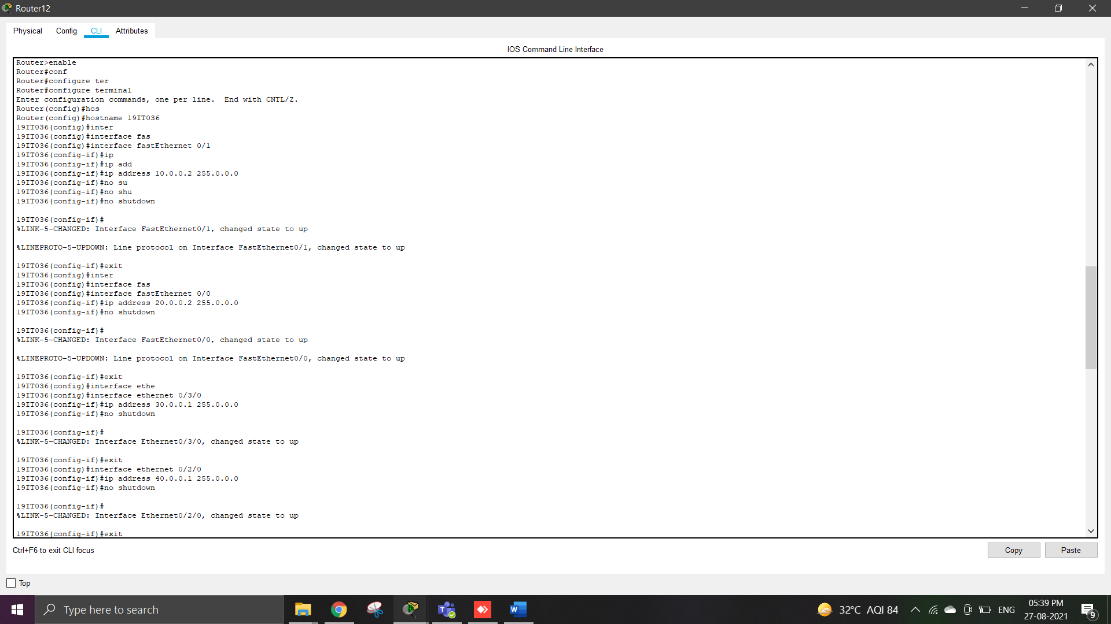

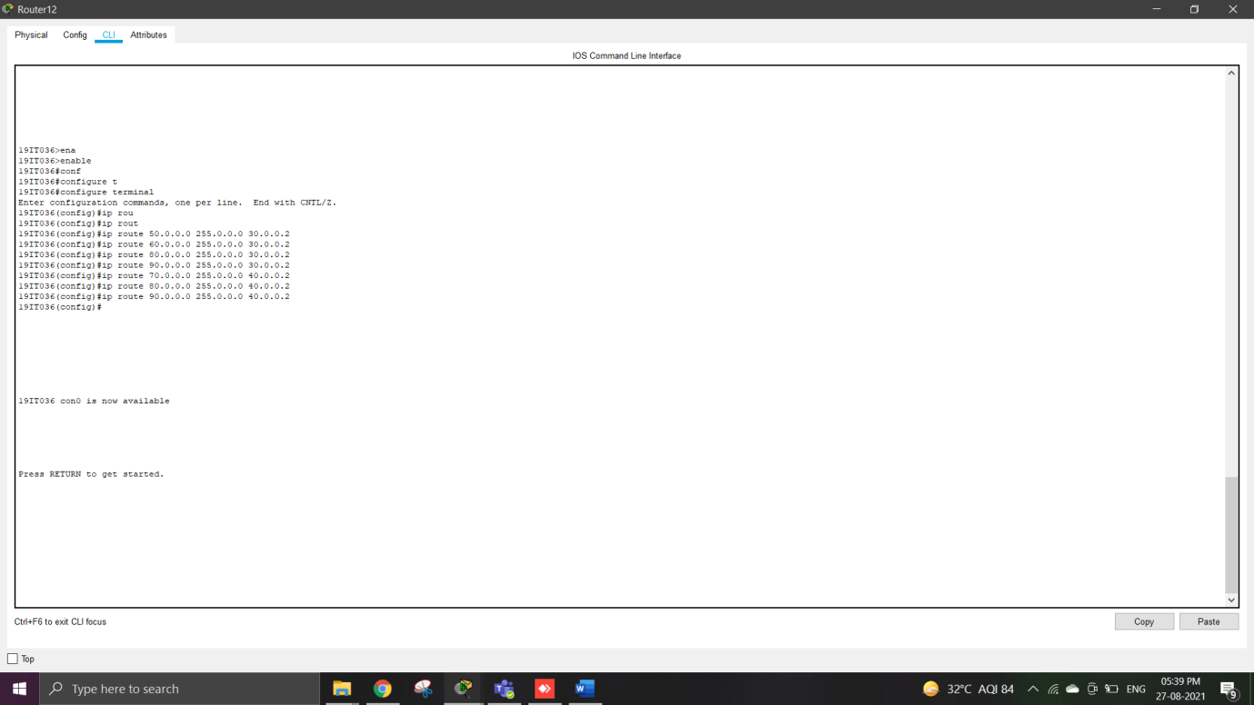

Route13:

* In router 13 first set ip address and than use command for routing.

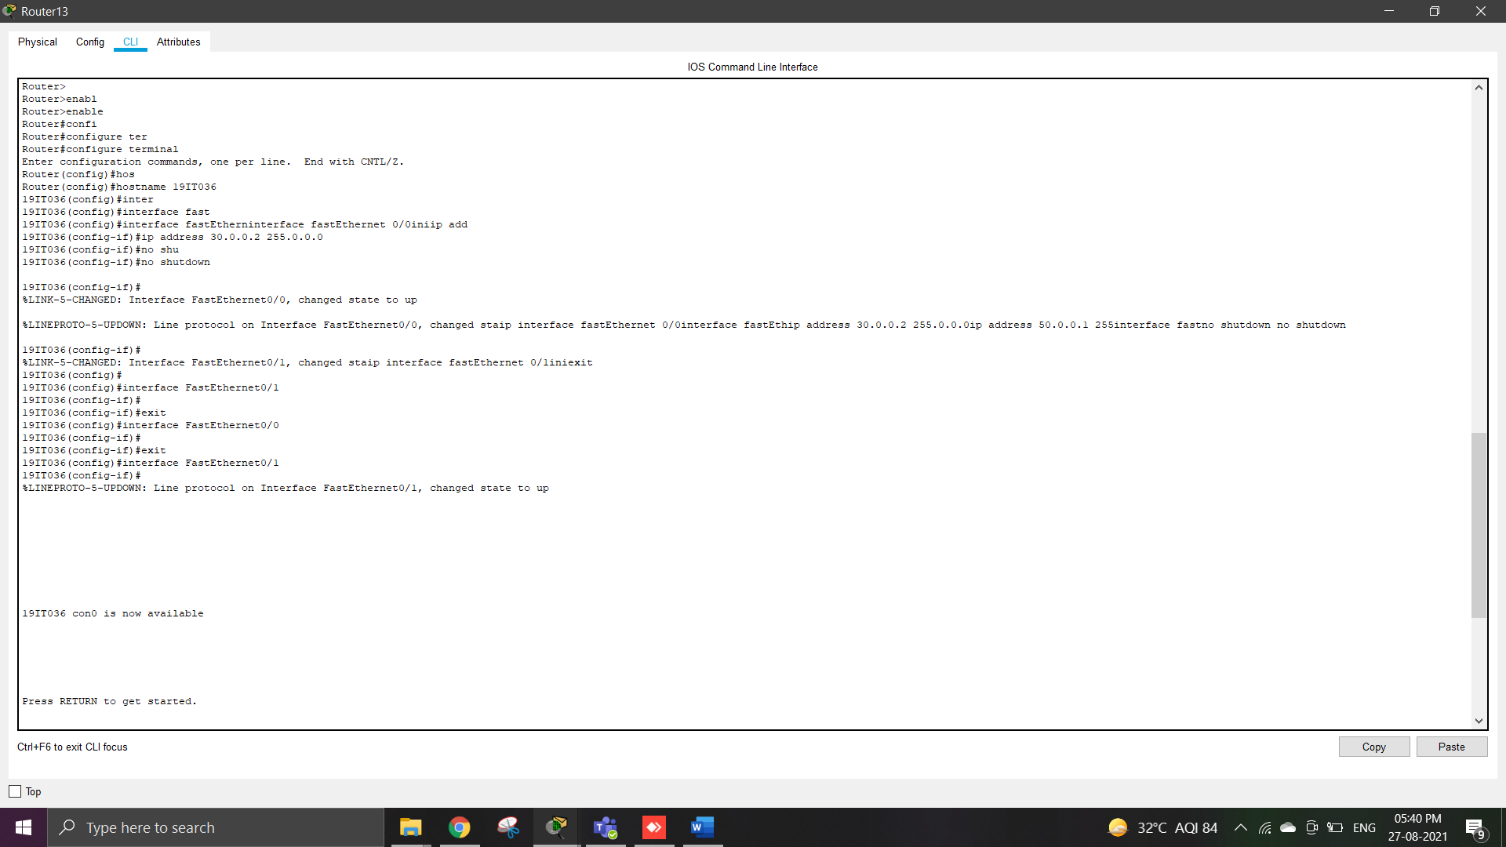

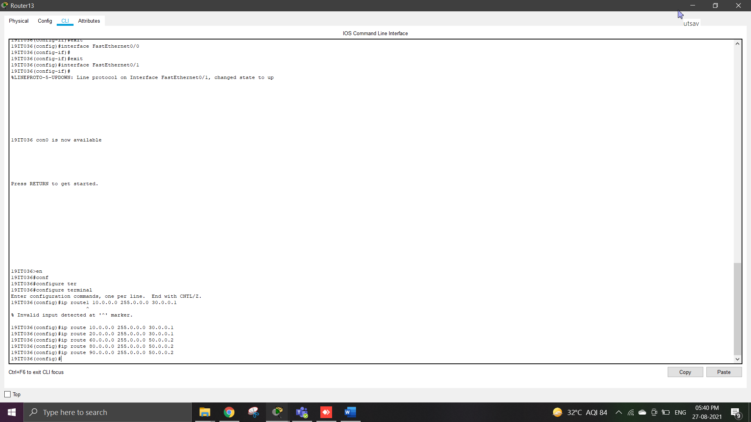

Route14:

* In router 14 first set ip address and than use command for routing.

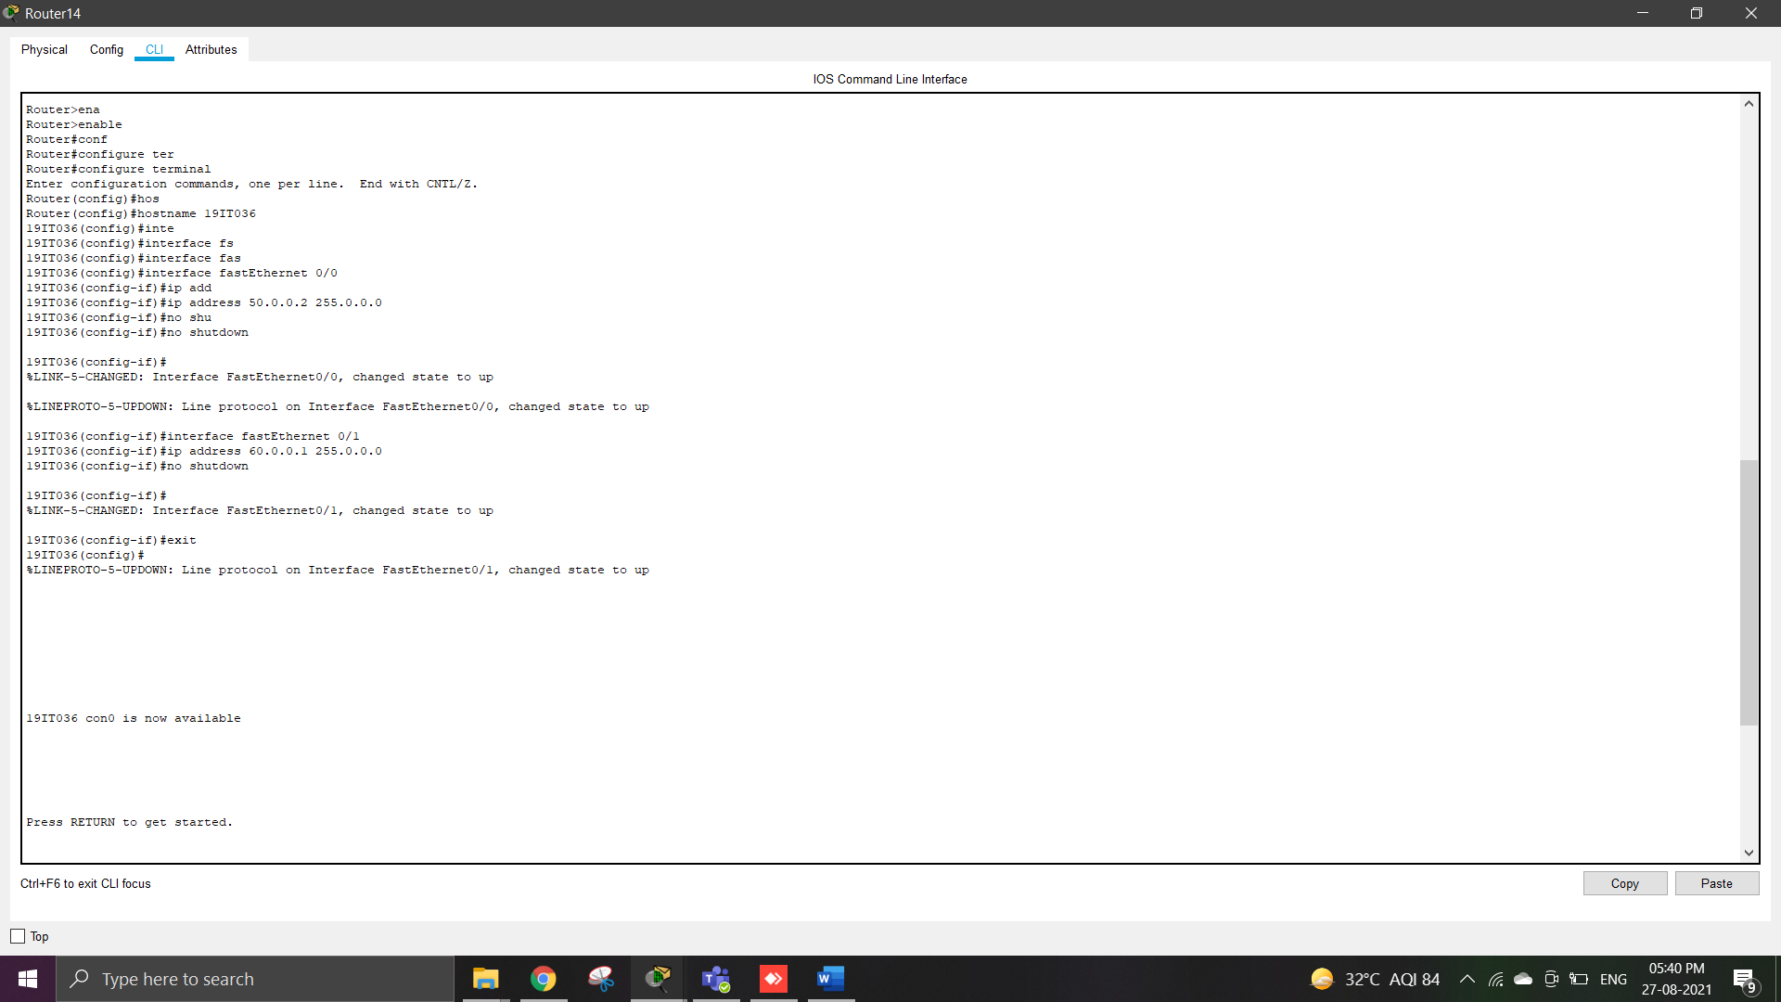

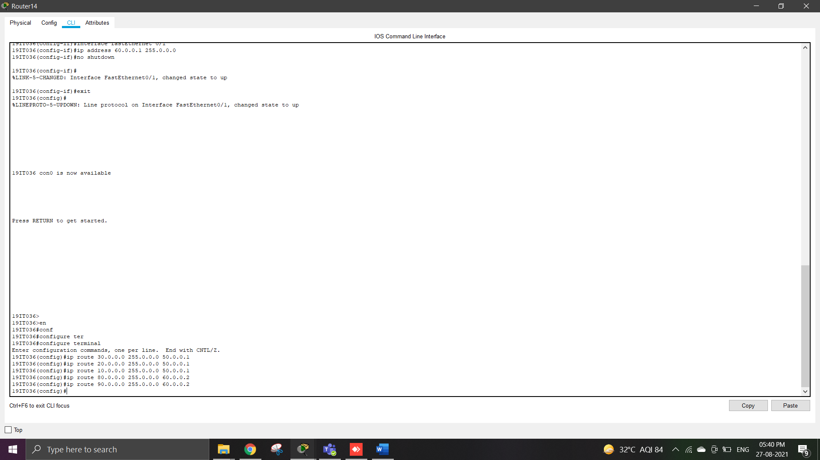

Route16:

* In router 16 first set ip address and than use command for routing.

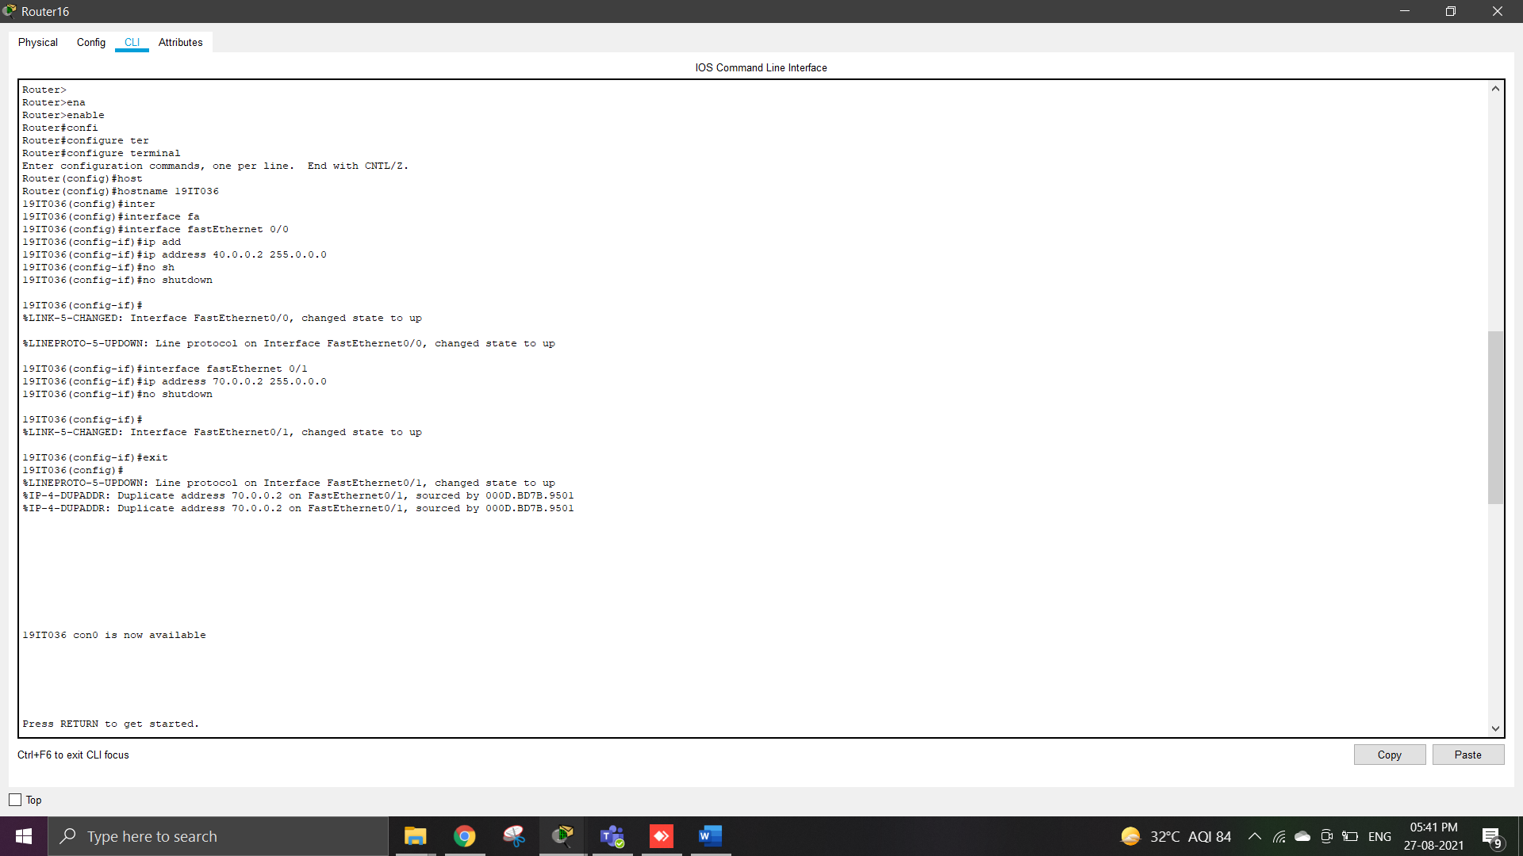

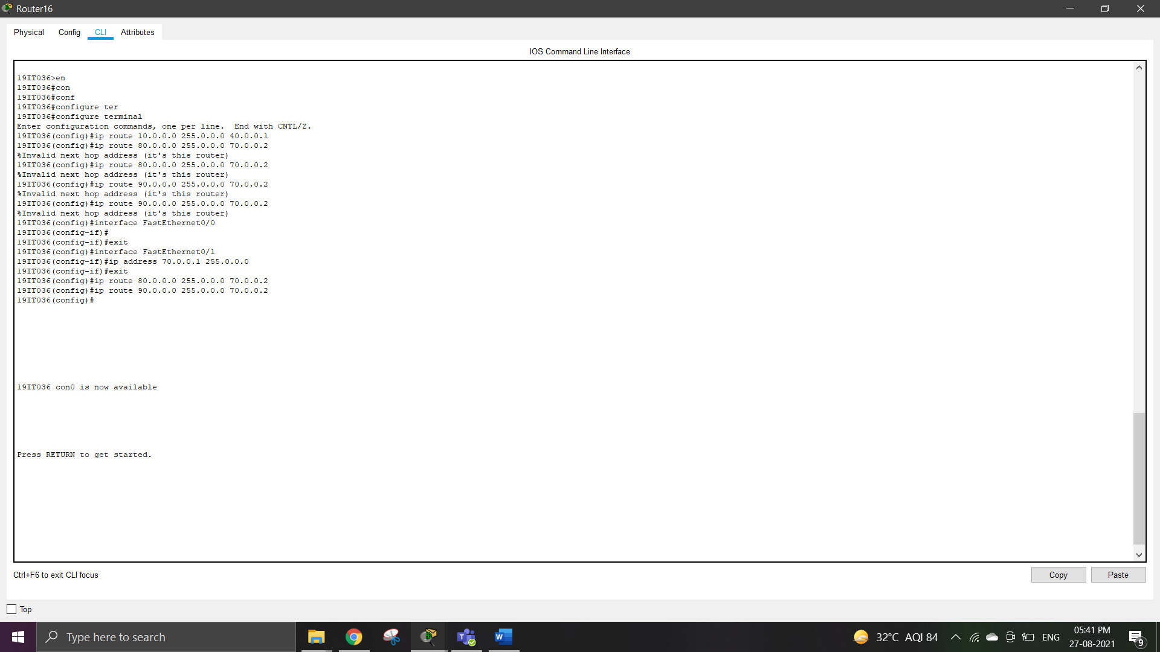

Route15:

* In router 15 first set ip address and than use command for routing.

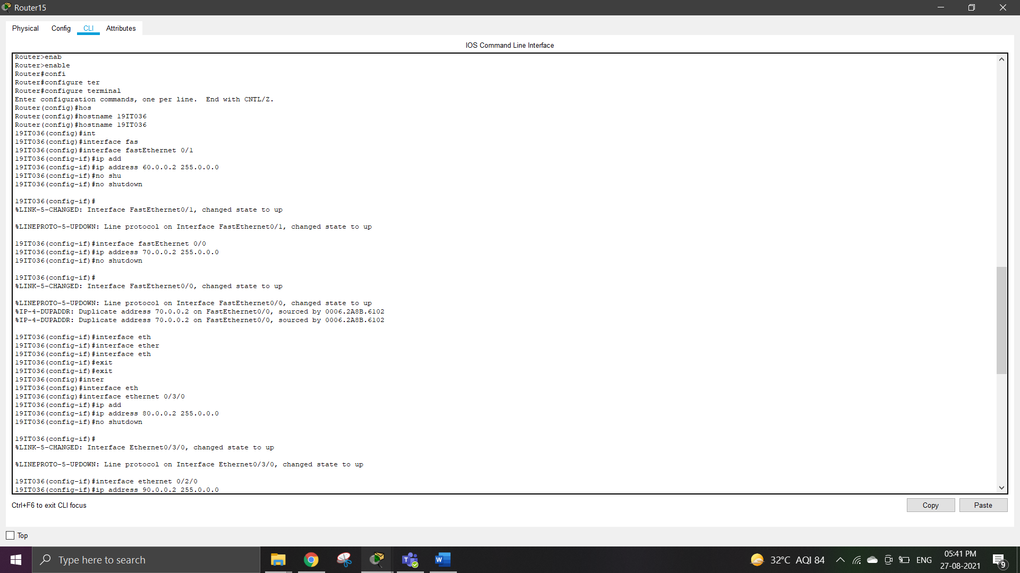

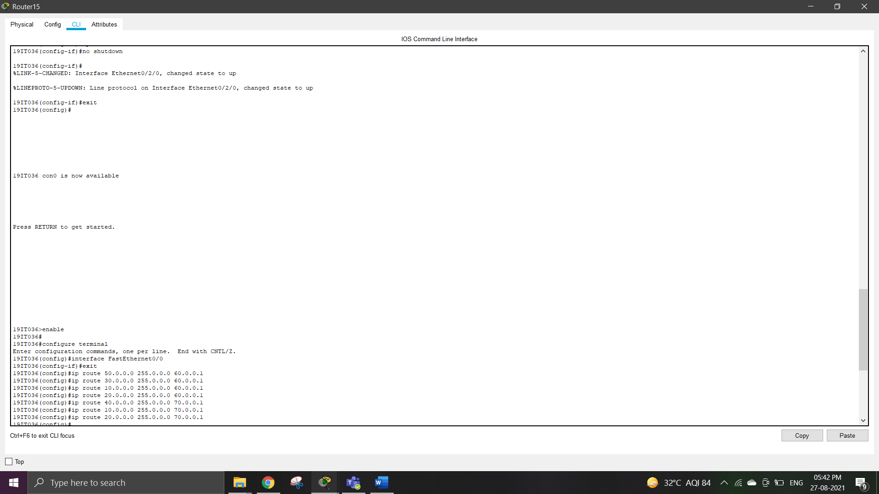

**OUTPUT:**

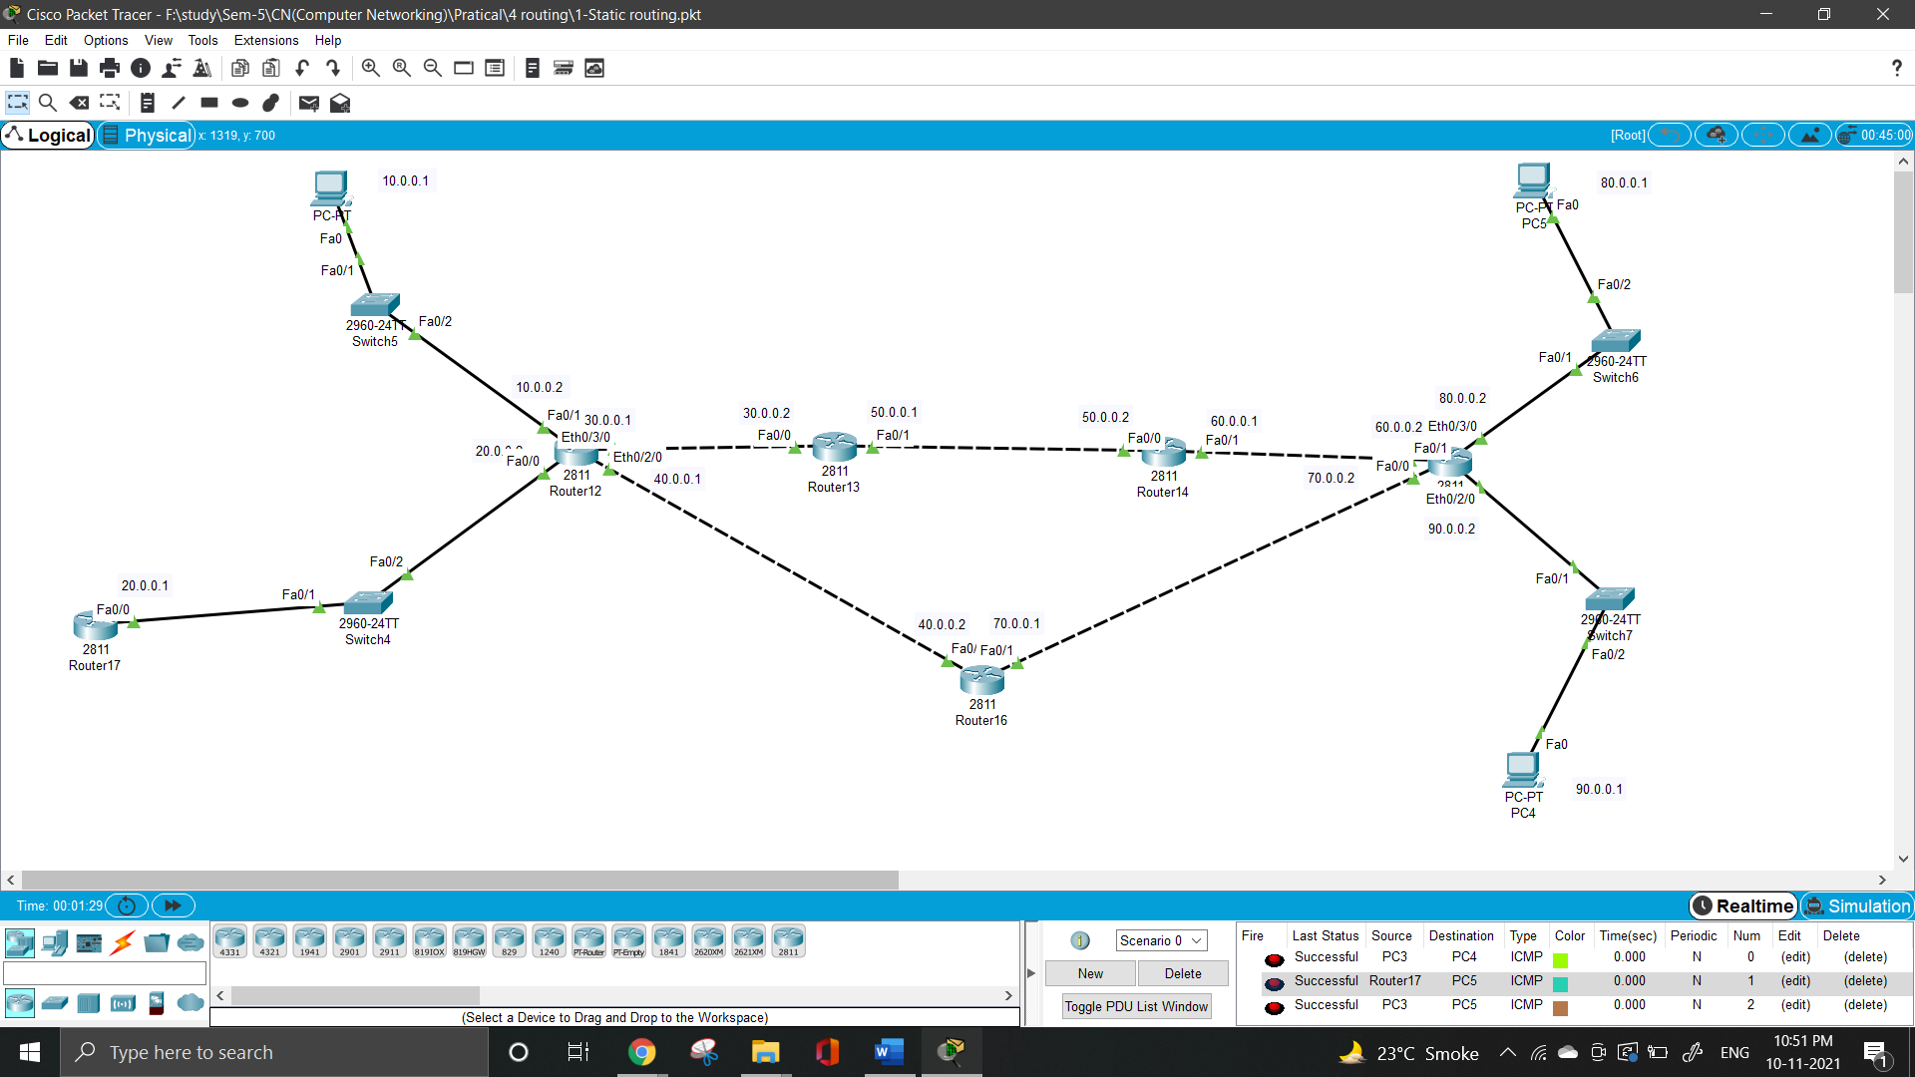

**LEARNING OUTCOME**: By performing this practical I understand what is static routing and what is default routing. In this practical we are doing routing using simple static routing.